**Node Js Questions**

1. Create a server in node-js to accept the request from the client. On receiving request send response either in HTML format or in Text format. Display message on console that Server running on local host
2. Write a program in Node js to create your own modules to perform arithmetic operations such as addition, subtraction, multiplication, division. Import these modules to create a calculator in another nodejs file
3. Write a program in node js to read the existing file data, display on console, and write the data in the existing file

(Hint use fs module of Node js)

1. Write a program in node js to read the existing file data, display on console, and delete he existing file

(Hint use fs module of Node js)

1. Create a server in node-js to accept the request from the client. On receiving request send HTML form in response. Display message on console that Server running on local host
2. Create a server in node-js to accept the request from the client. On receiving request send HTML Table in response. Display message on console that Server running on local host

**Express Questions**

1. Create server in express js to accept the request from the client. Based on the route specified by user send the response (Hint use get method)

If route is ‘/’- send response as information which will be displayed on browser

If route is ‘/books’ - send response as books information which will be displayed on browser

1. Create server in express js to accept the request from the client. Based on the route specified by user send the response (Hint use both get and post method and body parser)

If route is ‘/’- send response as HTML form.

On form submit use post method, get the data field in form and display in on the browser

**Mongo DB Questions**

1. Create Student Database, create collection student information and perform insert, update, remove operation.
2. Create Student Database, create collection student information and perform insert operation. Write the following queries:

Display student information who has secured more than 90%.

Display student information who failed the examination

Display student information who stays in Andheri

3. Create Mongo dB Schema using mongoose module and insert data into database

4. Create Mongo dB Schema using mongoose module and Find All data from data base and display on browser

5. Create Mongo dB Schema using mongoose module and find first data from data base and display on the browser

**React Questions**

1. Create a react application for rendering single element and rendering component having multiple elements

2. Create a react application for rendering components having multiple elements and reusing the components at multiple places.

3. Create a react application to build user defined component, export the component and import user defined component

4. Create a react application to Import and use CSS in react application

5. Create a react application to implement props in react application

6. Create a react application for Raising and handling event.

7. Create a react application to Use of react using State hook to increment and decrement value.

**Java Script Questions**

1. Write program to perform form validation using JavaScript

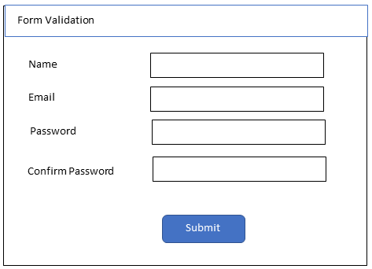

2. Write a program to search the string in the given program, display number of occurrences of string and replace the string with new string

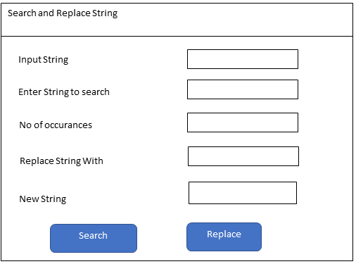

3. Write JavaScript program to display the even nos and odd nos from the given list

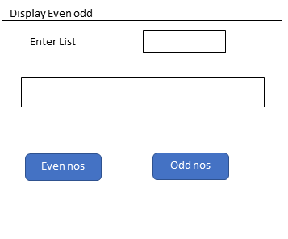

4. Write a program in JavaScript to take a list of numbers from user and double all the numbers and display the doubled list

5. Program to design a calculator using JavaScript

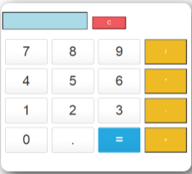

6. Write a JavaScript program to sort the items of an array.

7. Create a function that takes two numbers as arguments (number, length) and returns an array of multiples of number until the array length reaches length.

8. Create a function that determines whether a number is Oddish or Evenish. A number is Oddish if the sum of all its digits is odd, and a number is Evenish if the sum of all its digits is even. If a number is Oddish, return "Oddish". Otherwise, return "Evenish".

9. Create a function that will return the total number of digits in the given no as 234123 has 6 digits and Sum of all the digits

10. Write a JavaScript program to test whether the first character of a string is uppercase or not.

11. Write a JavaScript program to count and display the items of a dropdown list, in an alert window

**HTML and CSS Questions**

1. Create a static web page using HTML.

2. Create a class timetable using HTML.

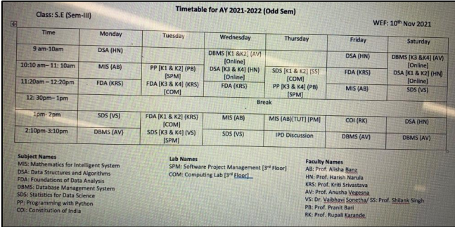

3. Create a registration form using HTML.



4. Design a web page using External or Embedded Style Sheet.

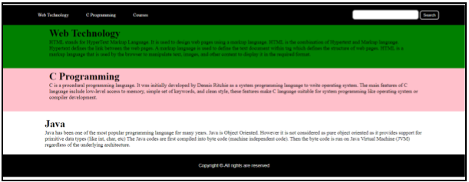

5. Design a responsive web page using media queries and CSS3.

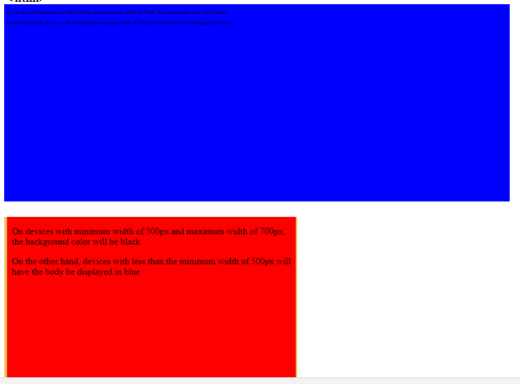

6. Design a web page using Bootstrap.

7. Design a resume using Bootstrap.

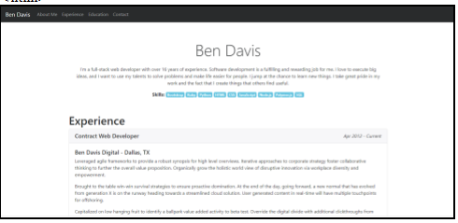

8. Design the admission form using Bootstrap.